

**ADDIS ABABA UNIVERSITY**

**INSTITUTE OF TECHNOLOGY CENTER OF EXCELLENCE**

**ITSE - 2192**

**WEB DESIGN AND DEVELOPMENT**

Written by: **Abel Abate**

ID**: ATR/6618/11**

Section: **01**

Title: **History of the internet and websites**

Submitted to: Mr. Fitsum A.

March, 2020

Addis Abeba

Contents

1. **History of the internet** 1

2. **Websites** 3

3. **Websites by category** 10

a. **Portal websites** 10

b. **News websites** 10

c. **Informational websites** 11

d. **Business/ Marketing websites** 12

e. **Educational websites** 14

f. **Entertainment websites** 15

g. **Advocacy websites** 16

h. **Blog websites** 16

i. **Wiki websites** 17

j. **Social Network websites** 18

k. **Content Aggregator websites** 19

**l.** **Personal websites** 20

4. **Guidelines for evaluating a website** 22

**References** i

**List of Figures** ii

# **History of the internet**

The internet is a tool we use throughout our day. It can be defined as a global communications network consisting of thousands of networks typically interconnected by fiber optic cabling .When we see the history of the internet it was created in order to facilitate faster and better communication flow between two entities. The Internet was first invented for military purposes, and then became a way for government researchers to share information. Computers in those days were very large and immobile and thus there needed to be an effective way to transfer information. The internet started to emerge in the 1960s it was developed by the US departments advanced research projects agency network and was called ARPANET. It was created in order to facilitate better communication between academic and research organizations. During the Cold War, it was essential to have communications links between military and university computers that would not be disrupted by bombs or enemy spies. In order to solve the problem, in 1968 DARPA (Defense Advanced Research Projects Agency) made contracts with BBN (Bolt, Beranek and Newman) to create ARPANET (Advanced Research Projects Agency Network).

The first recorded description of the social interactions that could be enabled through networking was a series of memos written by J.C.R. Licklider of MIT in August 1962 discussing his “Galactic Network” concept. He envisioned a globally interconnected set of computers through which everyone could quickly access data and programs from any site. In spirit, the concept was very much like the Internet of today. Licklider was the first head of the computer research program at DARPA. While at DARPA he convinced his successors at DARPA, Ivan Sutherland, Bob Taylor, and MIT researcher Lawrence G. Roberts, of the importance of this networking concept. Leonard Kleinrock at MIT published the first paper on packet switching theory in July 1961 and the first book on the subject in 1964. Kleinrock convinced Roberts of the theoretical feasibility of communications using packets rather than circuits, which was a major step along the path towards computer networking.

January 1, 1983 is considered the official birthday of the Internet. Prior to this, the various computer networks did not have a standard way to communicate with each other. A new communications protocol was established called Transfer Control Protocol/Internetwork Protocol (TCP/IP). This allowed different kinds of computers on different networks to "talk" to each other. ARPANET and the Defense Data Network officially changed to the TCP/IP standard on January 1, 1983, hence the birth of the Internet. All networks could now be connected by a universal language.

In the 1990s, the whole world started to change more drastically technological wise and the Internet began to affect people. The number of end systems connected to the Internet reached one million. One of the most important events that happened in the 1990s was the invention of the World Wide Web (WWW). The first Web was started in November 1990 by Tim Berners-Lee at CERN.(8)  With the start of WWW and browsers to surf the Internet, the commercialization emerged and has change the world tremendously (especially, with the development of the GUI browsers, such as, Mosaic Communications by Marc Andreesen and Jim Clark, which were later called Netscape Communications Corporations, and their opponent Microsoft Explorer).The recent development and widespread deployment of the World Wide Web has brought with it a new community, as many of the people working on the WWW have not thought of themselves as primarily network researchers and developers. Today, people can do almost anything that they can think of over the Internet: shopping, taking University level courses and obtaining University degrees, sending Instant Messages (IM), using the phone network, listening to the Internet talk radio, banking, buying and selling stock on the stock market.

# **Websites**

* 1. **Yahoo!**

Yahoo is an American web services provider which has been around since 1994. When the website first emerged it had a very simple look. The website was made only form list, paragraph anchor and form tags. It only contained one image as we can see for Figure 2.1.

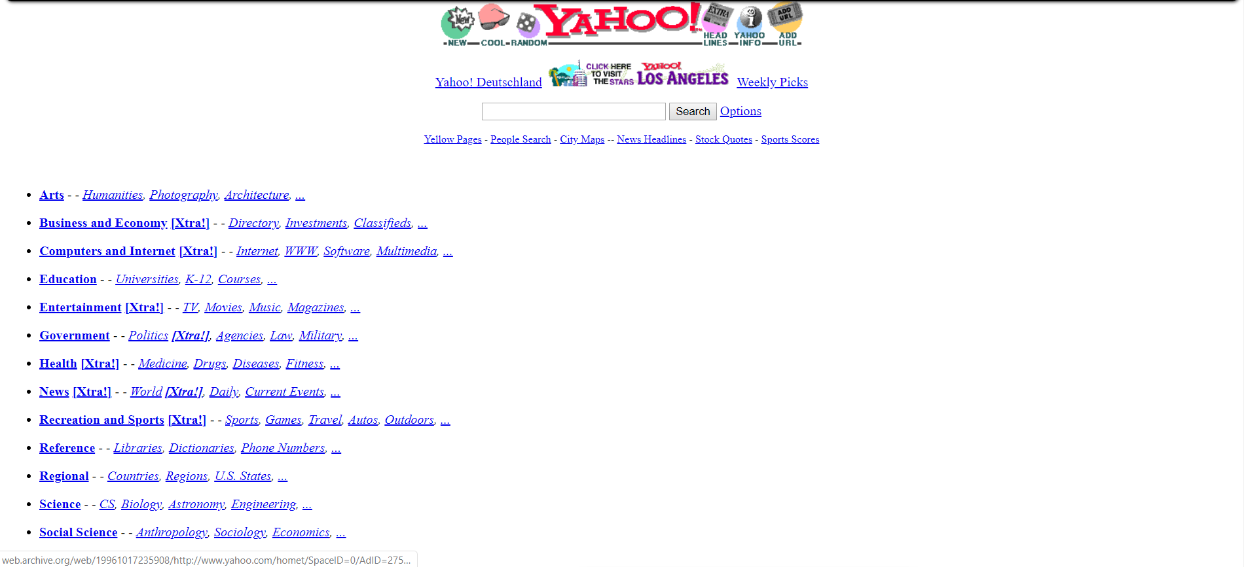

### Figure 2.1, Yahoo webpage 1996

Then in the 21th century as we can see in Figure 2.2 the website started to center its content and the also started using tables to align their contents. They also added more content to their webpage like Yahoo Mail. They also included clickable images. Their reference links didn’t change color when clicked or hovered over.

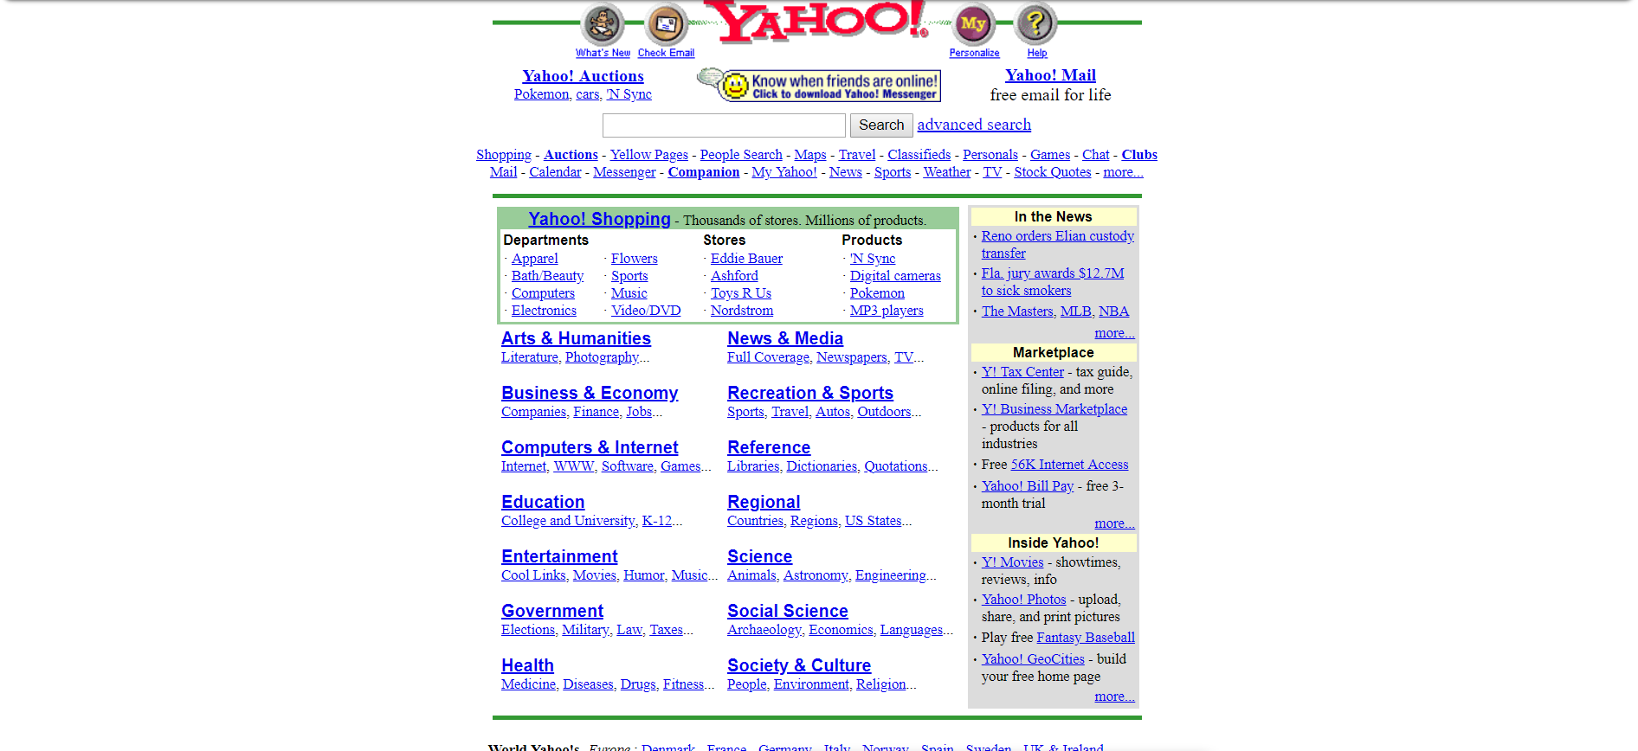

### Figure 2.2, Yahoo website 2000

In 2005 as we can see in Figure 2.3, the website still used tables to align its content. What new in this website is that they included a dating site.

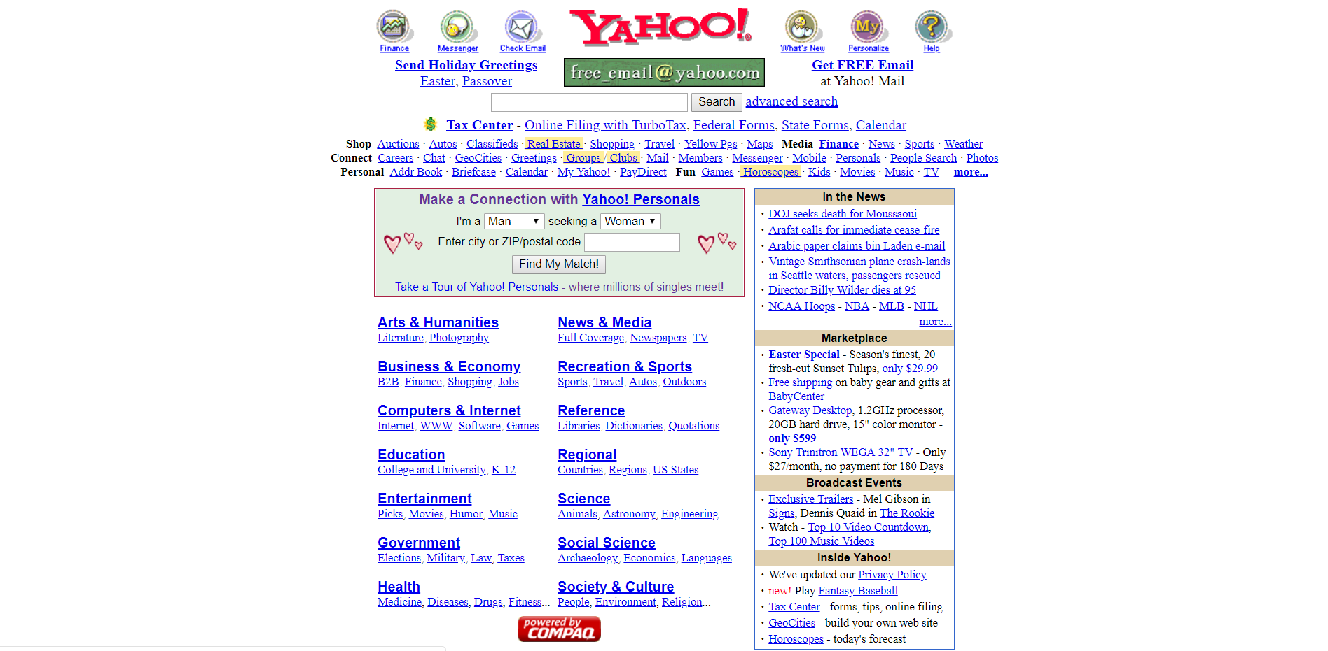

### Figure 2.3, Yahoo website 2005

In 2010, shown in figure 2.4 the website had major changes, they divided their content by header, content and footer. They changed the logo from red to purple and instead of making all their clickable links the default blue color with an underline they made it black, with an icon next to it on some of them. They placed their navigation bar on top and included a favorites table on the left. The also added advertisements.

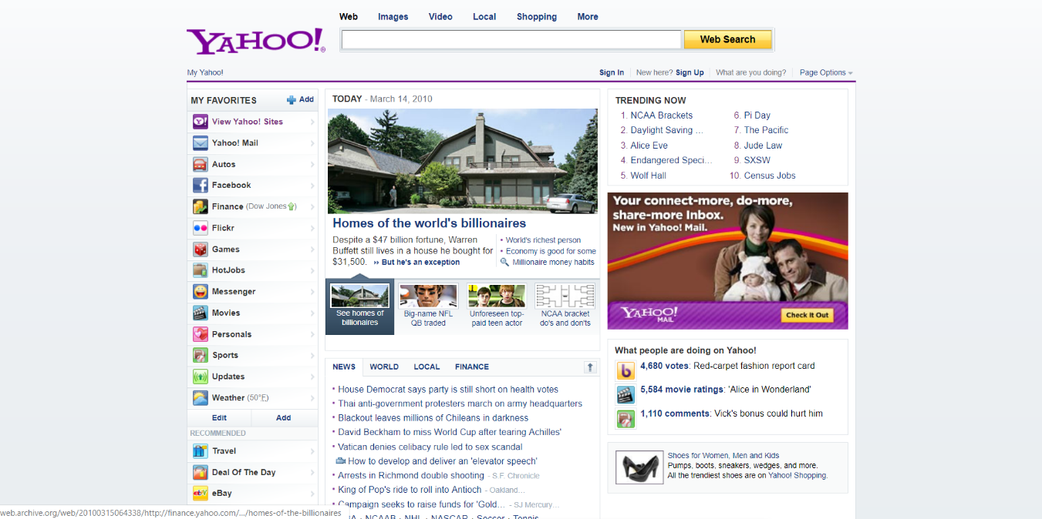

### Figure 2.4, Yahoo website 2010

In 2015, as shown in Figure 2.5 the website started to include icon in their title. They still put their search bar and their navigation on top but made their content scrollable. They changed the name of their button from web search to search web. They made the content size of the main page larger and also included a lot of content. They also removed the description column on bottom and made it next to the content on the bottom right corner. They changed the color of the logo from purple to dark blue.

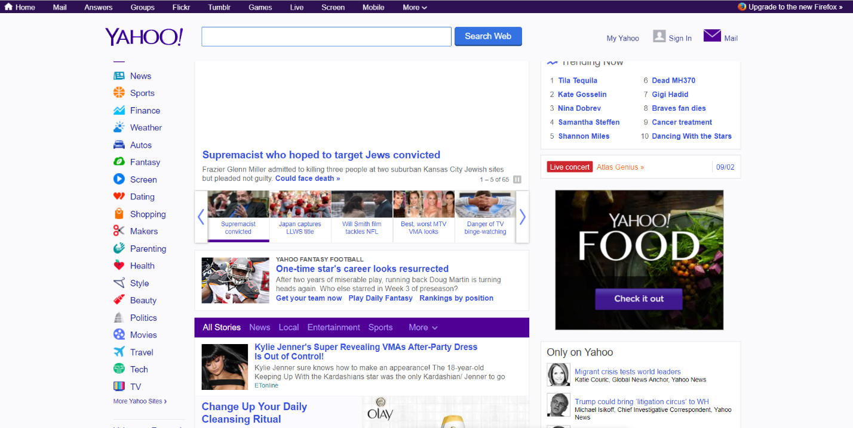

### Figure 2.5, Yahoo website 2015

Now, shown in Figure 2.6, the website decided to place their navigation bar below the search bar and also added a lot of content they also removed their more sites content. They made their page instead of the header scrollable. They made all their nav bar links purple. They removed icons from all clickable links. They made their search bar bigger and also change the button color to blue and change the button icon from text to image. They also made their navigation bar collapsible. They also removed the description table.

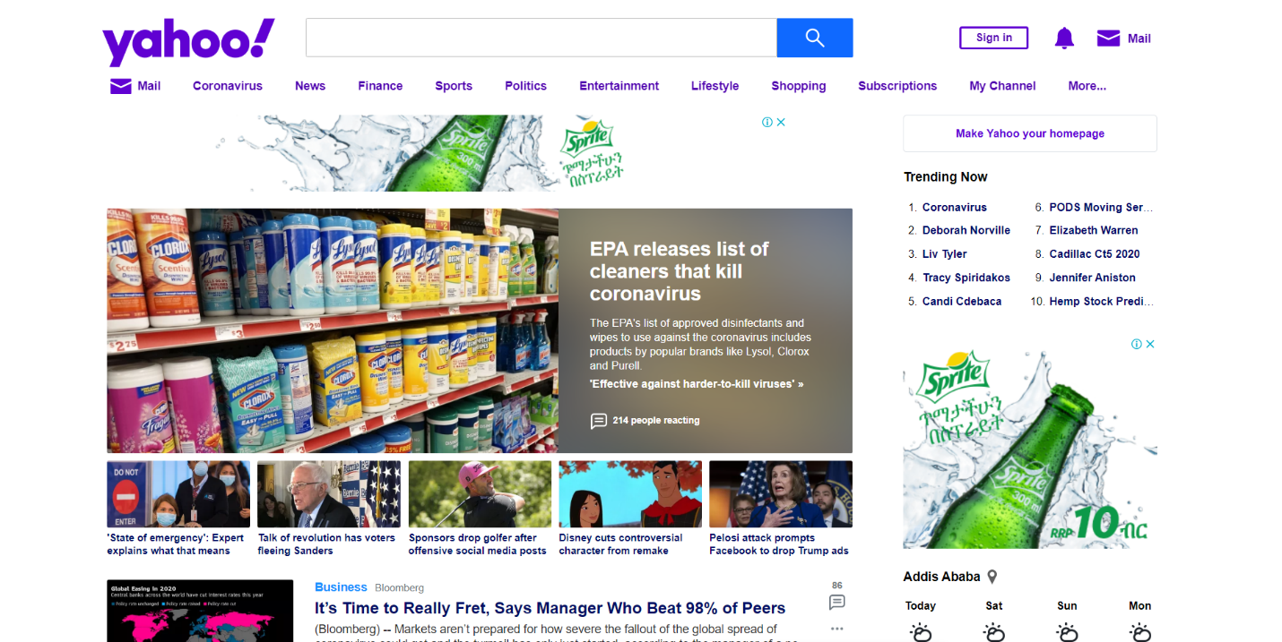

### Figure 2.6, Yahoo website 2021

* 1. **eBay**

eBay Inc. is an American multinational e-commerce corporation based in San Jose, California, that facilitates consumer-to-consumer and business-to-consumer sales through its website.

In 2000, as shown in Figure 3.1 the website like other websites in its time used tables to align its content. The web content was centered and everything was crammed together.

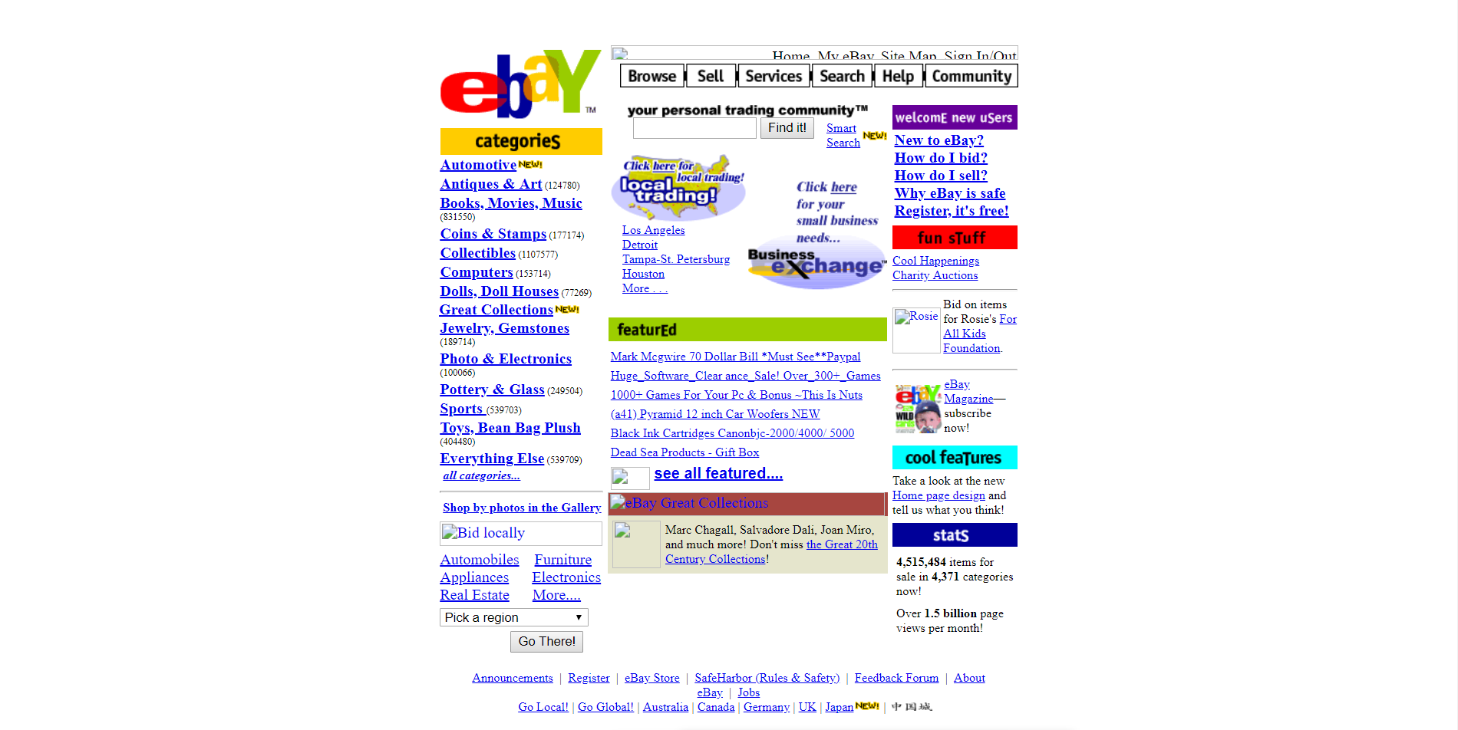

### Figure 3.1, Ebay website 2000

In 2005,as shown in figure 3.2 the website added more content and they added more images. They placed some of their content in color filled boxes. They had a search bar on the left and top part of the website.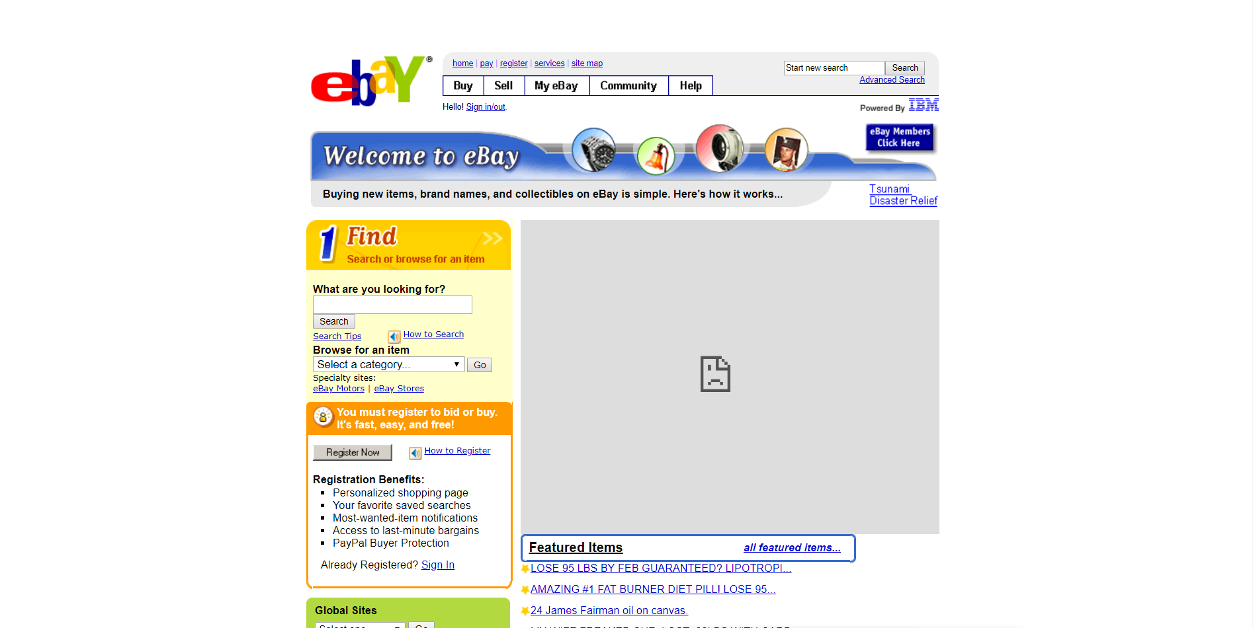

### Figure 3.2, Ebay website 2005

In 2010, as shown in Figure 3.3 the website placed their description box in a grey box below. They added a green color to their search button. They listed all their categories on the left bar but the links still had the default blue color with an underline. They stopped putting their content in color filled boxes. They added drop down buttons.

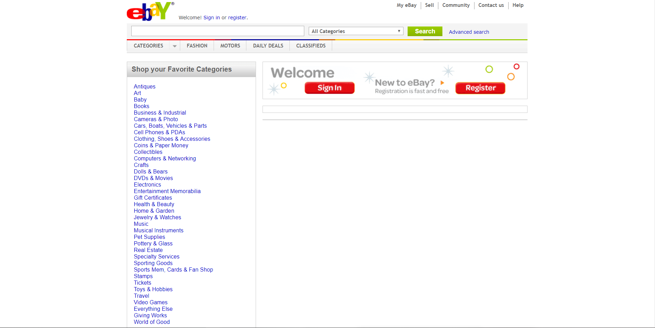

### Figure 3.3, Ebay website 2010

In 2015 the website, as shown in Figure 3.4 the website classified their content into header, middle and footer. They added image frames that changed by clicking a button. They started displaying their content image, price and description together. They added a go back to top button on the left bottom corner. They made their search button wider and changed the color to blue. They changed their page from a single page to a scrollable page. They changed their overlapping logo to plain text logo. They added clickable images.

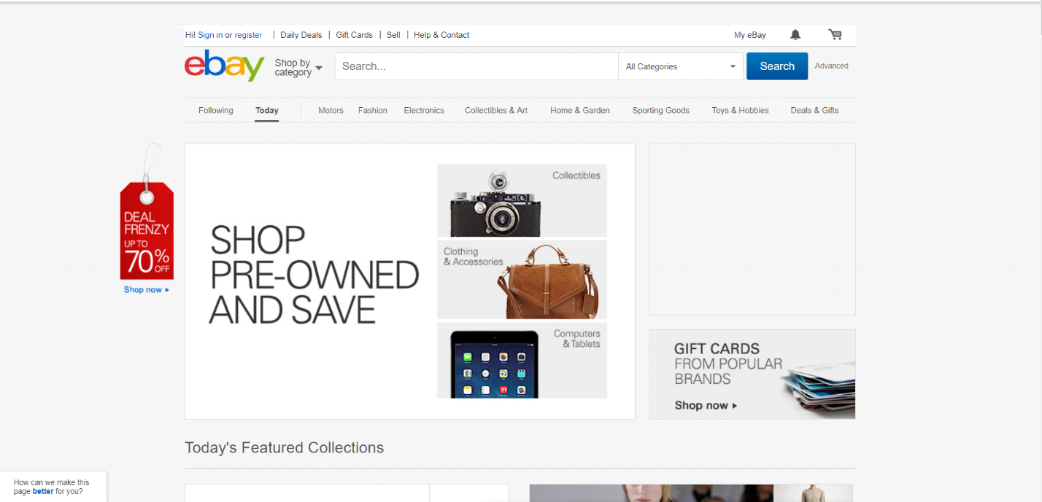

### Figure 3.4, Ebay website 2015

Now their websites has a changed a lot from the previous years, as shown in Figure 3.5 they added an automatic changing image content. They added a rounded image content classifiers. They added a floating help button slightly above the right bottom corner of the webpage. They placed their navigation bar beneath their search bar.

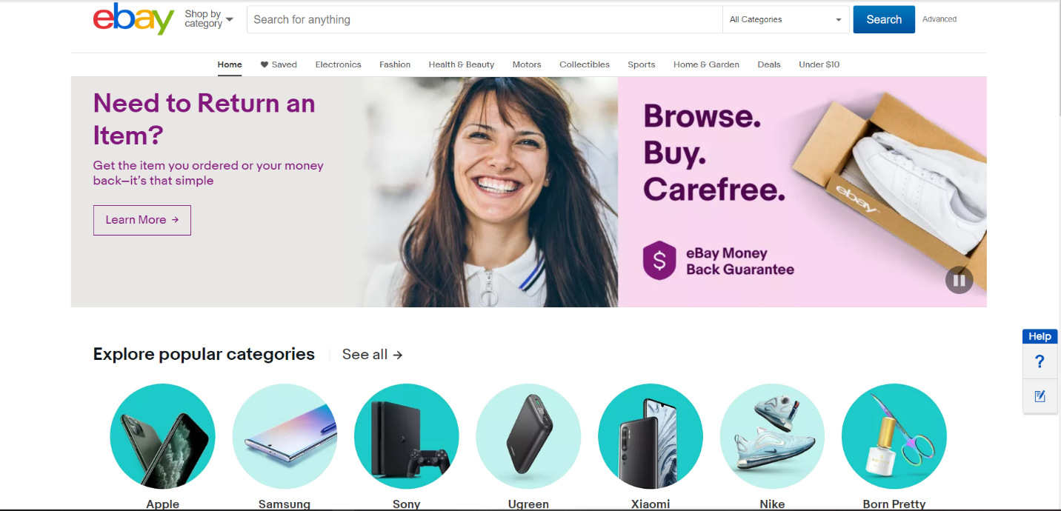

### Figure 3.5, Ebay website 2021

# **Websites by category**

* 1. **Portal websites** – is a web based platform that provides employees, customers and suppliers with a single access point to information.
     1. Addis Ababa Institute of Technology - <http://portal.aait.edu.et>
        + - Is a site which helps students view their grades and apply to courses.
     2. Allianz - <http://www.allianz.com>
        + - is a site which offers users with the ability to retrieve historiacal records of purchased products and services along with integrated features to facilitate policy payments and renewals.
     3. UAB Medicine - <http://www.uabmedicine.org/>
        + - A site where medical professionals can reach many visitors and actual patients with health concerns.
     4. Grants.gov - <http://www.grants.gov/>
        + - A site which allows applicants for federal government’s to apply for and manage grant funds online through a common website.
     5. Stanford University AXESS - <http://axess.sahr.stanford.edu/>
        + - Is an online platform for the academic community to access information and record various transactions.
  2. **News websites** – are websites that deliver the news online.
     1. CNN- <https://edition.cnn.com/>
        + - An American news based that delivers up-to-the-minute news and information on the latest top stories, weather, entertainment, politics and more.
     2. USA Today - <https://www.usatoday.com/>
        + - A website that delivers current local and national news, sports, entertainment, finance, technology, and more through award winning journalism, photos, videos and VR.
     3. New York Times - <https://www.nytimes.com/>
        + - A website that provides breaking news, multimedia reviews and opinion on Washington, business, sports, movies, travel, books, jobs, education, real estate, cars and more.
     4. The Huffington Post - <https://www.huffpost.com/>
        + - The destination for news, blogs and original content offering coverage of US politics, entertainment, style, world news, technology and comedy.
     5. CBS News - <https://www.theguardian.com/>
        + - Is a website dedicated to providing the best in journalism under standards it pioneered at the dawn of radio and television and continue in the digital age.
  3. **Informational websites** – are websites which are designed in order to provide a customized and branded resource for potential and active customers, members and investors.
     1. Cnet - <http://www.cnet.com/>
        + - CNET.com provides tech news; product review, and prices, offer software downloads. This is listed as one of the most informative websites categorized in technology news and information.
     2. AOL – <http://www.aol.com/>
        + - AOL Inc. is a New York City based multinational mass media corporation. And website of AOL Inc. has ranked one of the informative websites.
     3. Nobelprize.org - <http://www.nobelprize.org/>
        + - Nobelprize.org one of the informative websites, if you are students, scholars this website can encourage you. Find out yourself more about Nobelprize.org.
     4. Guiness world records - <http://www.guinnessworldrecords.com/>
        + - This is the official website of Guinness World Records. Guinness World Records has been inspiring, engaging and entertaining 1995
     5. WHO - <http://www.who.int/>
        + - Website of WHO (World Health Organization) is one of the top 10 most informative websites. It provides disease outbreak news, information about emergencies and disasters, factsheets and related information.
  4. **Business/ Marketing websites** - is the process of using the Internet to market your business. It includes the use of social media, search engines, blogging, videos, and email.
     1. DMN – <https://www.dmnews.com/>
        + - DMN is a resource for marketing and sales professionals that explores all realms of digital and data driver marketing in an unbiased and incisive manner. DMN distributes content via newsletters, eBooks, webcasts, podcasts, and custom projects and publications.
     2. Chief marketer - <http://www.chiefmarketer.com/>
        + - Chief Marketer serves marketing professionals of consumer and business-to-business brands with rich and thorough information on measurable marketing strategies, tactics, and technique. Chief Marketer provides well thought out insights and ideas, accompanied by resources and technologies in a method to measure return on investment.
     3. Fortune – <https://www.fortune.com/>
        + - Fortune is one of the world’s leading business media brands which is accompanied by a multinational monthly magazine, daily website and conference series. Fortune is dedicated to assisting its readers, viewers, and attendees to succeed in the business sector.
     4. Adage – <https://www.adage.com/>
        + - Ad Age is a daily must-read source of news for individuals within the marketing and media sector. Ad Age is a global media brand that provides emphasis on curated creativity, data and analysis, people and culture, and innovation and forecasting.
     5. MarketingProfs - <https://www.marketingprofs.com/>
        + - MarketingProfs aims to serve marketers by providing practical marketing training and education on everything from developing, executing, and measuring successful campaigns.
  5. **Educational websites** – are websites that have games, videos or topic related resources that act as tools to enhance learning and supplement classroom teaching.
     1. Crash course - <https://www.thecrashcourse.com/>
        + - Is a website that transforms traditional textbook model by presenting information in a fast-paced format, enhancing the learning experience.
     2. Khan academy – <https://www.khanacademy.org/>
        + - Is an online coaching website. Students who cannot afford a coaching can refer to this website. It gives a win-win situation to the students by giving them the liberty to learn on their own pace.
     3. Edx - <https://www.edx.org/>
        + - It was founded by Harvard University, offering high-quality courses form the world’s best universities and institutions to learners everywhere.
     4. Web archive - <https://web.archive.org/>
        + - Is an authentic website storing the originals from various big websites.
     5. Udemy - <https://www.udemy.com/>
        + - Is one of the most reputable online learning platforms. Students and adults who can find plenty of courses and studying materials on subjects which interests them the most.
  6. **Entertainment websites** – delivering any form of entertainement online.
     1. Tmz - <https://www.tmz.com/>
        + - Breaking the biggest stories in celebrity and entertainment news. Get exclusive access to the latest stories, photos, and video as only TMZ can.
     2. Netflix - <https://www.netflix.com/>
        + - Is the world’s leading internet television network with more than 36 million
     3. Popsugar - <https://www.popsugar.com/>
        + - POPSUGAR delivers the biggest moments, the hottest trends, and the best tips in entertainment, fashion, beauty, fitness, and food and the ability to shop for it all goods.
     4. IMDB - <https://www.imdb.com/>
        + - IMDb is the world's most popular and authoritative source for movie, TV and celebrity content. Find ratings and reviews for the newest movie and TV shows.
     5. Youtube - <https://www.youtube.com/>
        + - Enjoy the videos and music you love, upload original content, and share it all with friends, family, and the world on YouTube.
  7. **Advocacy websites** – are types of website that aim to influence decision within political, economic and social institutions.
     1. Change – <https://www.change.org/>
        + - Is the world’s largest social change platform.
     2. Justice For children - <https://www.justiceforchildren.org/>
        + - Website built for finding justice.
     3. Stop violence against women - <https://www.stopvaw.org/>
        + - Fighting for women and stopping attacks against them.
     4. National Black Child Development Institute - <https://www.nbcdi.org/>
        + - Website for improving the lives of children.
     5. National Coalition For Cancer Survivorship - <https://www.canceradvocacy.org/>
        + - Website for people who survived cancer.
  8. **Blog websites** – is an online journal or informational website. It is a platform where a writer or even a group of writers share their views on an individual subject.
     1. WordPress - <https://www.wordpress.com/>
        + - WordPress is one of the most popular free blogging platforms on the Internet. Millions of users like the options it provides for simple, free blog creation and maintenance. The platform is free and offers services such as hosting, the ability to have a custom domain, integrating your blog with social media and popular features such as comments and polls are available without installing plugins.
     2. Joomla - <https://www.joomla.org/>
        + - Is a free open-source content management system for publishing web content.
     3. Medium - <https://www.medium.com/>
        + - Is a place to read articles on the internet.
     4. Blogger - <https://www.blogger.com/>
        + - Is a blog-publishing service that allows multi-user blogs with time-stamped entries.
     5. Drupal.org - <http://www.drupal.org/>
        + - Drupal is a great option for blogs associated with businesses because it is not just a blogging platform, but a complete content management system. This means that along with your blog, web pages and other online content can be created and organized within this platform
  9. **Wiki websites** – is a community-edited website that acts as a knowledge base for a particular subject matter.
     1. WikiHow - <https://www.wikihow.com/>
        + - Learn how to do anything with wikiHow, the world’s most popular how-to website. Easy, step-by-step, illustrated instructions for everything.
     2. WikiBooks - <https://www.wikibooks.org/>
        + - Wikibooks is a Wikimedia community creating a free library of educational textbooks that anyone can edit.
     3. Wikia - <https://www.wikia.com/>
        + - Wikia is a community site that anyone can contribute to. Discover, share and add your knowledge!
     4. Wikipedia - <https://www.wikipedia.org/>
        + - A free encyclopedia with millions of articles contributed collaboratively using Wiki software, in dozens of languages.
     5. Wiktionary - <https://www.wiktionary.org/>
        + - Collaborative project for creating a free lexical database in every language, complete with meanings, etymologies, and pronunciations.
  10. **Social Network websites** – is an online platform that allows users to create a public profile and interact with other users on the website.
      1. Instagram - <https://www.instagram.com/>
         + - A simple, fun & creative way to capture, edit & share photos, videos & messages with friends & family.
      2. WeChat - <https://www.wechat.com/>
         + - WeChat grew from a messaging app, just like WhatsApp and Messenger, into an all-in-one platform. Besides messaging and calling, users can now use WeChat to shop online and make payment offline, transfer money, make reservations, book taxis, and more
      3. Whatsapp - <https://www.whatsapp.com/>
         + - WhatsApp is a messaging app used by people in over 180 countries. Initially, WhatsApp was only used by people to communicate with their family and friends. Gradually, people started communicating with businesses via WhatsApp. (When I was in Bangkok to buy a new suit, I communicated with the tailor via WhatsApp.)
      4. Facebook - <https://www.facebook.com/>
         + - Facebook is the biggest social media site around, with more than two billion people using it every month. That’s almost a third of the world’s population! There are more than 65 million businesses using Facebook Pages and more than six million advertisers actively promoting their business on Facebook, which makes it a pretty safe bet if you want to have a presence on social media.
      5. Twitter - <https://www.twitter.com/>
         + - Sign in now to check your notifications, join the conversation and catch up on Tweets from the people you follow.
  11. **Content Aggregator websites** – are websites that don’t produce their own content. Instead, they collect content from other websites around the internet and aggregate it into one easy to find location
      1. Feedly - <https://feedly.com/>
         + - Feedly is an excellent way to follow news. I particularly like the vertical organization over the grid organization you find on other sites.
      2. Usepanda - <https://usepanda.com/app/>
         + - Panda is a great tool for anyone working as a web designer, developer, or who has the entrepreneurial spirit. It is unique among aggregator sites because it follows Dribble, Behance, Product Hunt, GitHub. Not to mention Hacker News. Aggregating the aggregators!
      3. Techmeme - <https://www.techmeme.com/>
         + - A brilliant technology-themed aggregator site that pulls in tech stories from all over the spectrum. It includes sites like Reddit alongside breaking business news.
      4. Metacritic - <http://www.metacritic.com/>
         + - It is a review aggregator, like Rotten Tomatoes, but it also includes games and music.
      5. Science news - <http://esciencenews.com/>
         + - Popular science has never been more deserving of the name, and this aggregator is a good way to stay updated with the breakthroughs.
  12. **Personal websites -** websites about individuals
      1. Krista grey - <http://www.kristagray.com/>
         + - Gray’s homepage gives you all the basic information you need to know about her and her work in a clean, easy-to-read way. Plus, her “services” section explains exactly what she’s looking for, making it easy for people to understand how they can work with her.
      2. Ximena vengoechea - <http://www.ximenavengoechea.com/>
         + - The simple, clean design of this site makes the colors of Vengoechea’s illustrations and user design screenshots really pop—helping her work shine even more.
      3. Rachel G king - <http://www.rachaelgking.com/>
         + - King uses her simple website to tell a compelling story about herself—and then give a clear call to action for people to reach out to her to work together. Plus, her social profiles stand out loud and proud, which is critical since she’s a social media professional.
      4. Devon stank - <https://www.devonstank.com/>
         + - There’s no question about what this guy does. But, in addition to the simple, clear welcome screen, Stank does a stellar job of integrating information about his skills and abilities with just enough personality to stand out.
      5. Kristi hines - <http://kristihines.com/>
         + - Hines has managed to make the examples of her writing work visual with the help of publication logos—plus, her testimonials page is second to none.

# **Guidelines for evaluating a website**

1. AUTHORITY

Authority reveals that the person, institution or agency responsible for a site has the qualifications and knowledge to do so. Evaluating a web site for authority:

* Authorship: It should be clear who developed the site.
* Contact information should be clearly provided: e-mail address, snail mail address, phone number, and fax number.
* Credentials: the author should state qualifications, credentials, or personal background that gives them authority to present information.
* Check to see if the site supported by an organization or a commercial body

1. PURPOSE

The purpose of the information presented in the site should be clear. Some sites are meant to inform, persuade, state an opinion, entertain, or parody something or someone. Evaluating a web site for purpose:

* Does the content support the purpose of the site?
* Is the information geared to a specific audience (students, scholars, general reader)?
* Is the site organized and focused?
* Are the outside links appropriate for the site?
* Does the site evaluate the links?
* Check the domain of the site. The URL may indicate its purpose.

1. COVERAGE

It is difficult to assess the extent of coverage since depth in a site, through the use of links, can be infinite. One author may claim comprehensive coverage of a topic while another may cover just one aspect of a topic. Evaluating a web site for coverage:

* Does the site claim to be selective or comprehensive?
* Are the topics explored in depth?
* Compare the value of the site’s information compared to other similar sites.
* Do the links go to outside sites rather than its own?
* Does the site provide information with no relevant outside links?

1. CURRENCY

Currency of the site refers to; how current the information presented is, and how often the site is updated or maintained. It is important to know when a site was created, when it was last updated, and if all of the links are current. Evaluating a web site for currency involves finding the date information was:

* first written
* placed on the web
* last revised

Then ask if:

* Links are up-to-date
* Links provided should be reliable. Dead links or references to sites that have moved are not useful.
* Information provided so trend related that its usefulness is limited to a certain time period?
* the site been under construction for some time?

1. OBJECTIVITY

Objectivity of the site should be clear. Beware of sites that contain bias or do not admit its bias freely. Objective sites present information with a minimum of bias. Evaluating a web site for objectivity:

* Is the information presented with a particular bias?
* Does the information try to sway the audience?
* Does site advertising conflict with the content?
* Is the site trying to explain, inform, persuade, or sell something?

1. ACCURACY

There are few standards to verify the accuracy of information on the web. It is the responsibility of the reader to assess the information presented. Evaluating a web site for accuracy:

* Reliability: Is the author affiliated with a known, respectable institution?
* References: do statistics and other factual information receive proper references as to their origin?
* Does the reading you have already done on the subject make the information seem accurate?
* Is the information comparable to other sites on the same topic?
* Does the text follow basic rules of grammar, spelling and composition?
* Is a bibliography or reference list included?

**Amazon**

Amazon is the world's largest online retailer and a prominent cloud services provider. Their website clearly provides their address and also their website developers. The website also fulfills its purpose and is also easy to access and well built. Their website shows that it’s up to date.

**Internet Society** - <https://www.internetsociety.org/internet/history-internet/brief-history-internet/>

The website displays information in a very well manner. It displays their address and reveales that their content is up to date. It perfectly states who the authors of the websites are and where they got the information. The authors are also from prominent institutions. The website doesn’t also display advertisement that may block contetnt to the viewer. The site is also very well organized and easy to navigate.

# **References**

* https://wpmayor.com/6-best-examples-content-aggregator-websites/
* https://websitesetup.org/best-blog-sites/
* https://www.library.wisc.edu/socialwork/research-help/social-issues-websites/advocacy-websites/
* https://www.elinkdesign.com/web-services/web-design/web-design/informational-web-sites
* https://k12teacherstaffdevelopment.com/tlb/how-do-i-introduce-students-to-educational-websites/
* https://www.makeuseof.com/tag/13-popular-wikis-that-actually-work/
* https://www.codelessplatforms.com/blog/what-is-a-web-portal/
* https://liferay.dev/blogs/-/blogs/15-awesome-web-portal-examples
* https://blog.feedspot.com/usa_news_websites/
* <https://www.indiatoday.in/education-today/featurephilia/story/free-education-953499-2017-01-06>
* <https://cdn.dal.ca/pdf/CoreSkills>
* https://sites.cs.ucsb.edu/~almeroth/classes/F04.176A/homework1_good_papers/Alaa-Gharbawi.html
* <https://www.usg.edu/galileo/skills/unit07/internet07_02.phtml>
* http://justinterview.blogspot.com/2013/10/webinformation-most-informative-websites.html

# **List of Figures**

Figure 2.1, Yahoo webpage 1996 3

Figure 2.2, Yahoo website 2000 4

Figure 2.3, Yahoo website 2005 4

Figure 2.4, Yahoo website 2010 5

Figure 2.5, Yahoo website 2015 6

Figure 2.6, Yahoo website 2021 6

Figure 3.1, Ebay website 2000 7

Figure 3.2, Ebay website 2005 7

Figure 3.3, Ebay website 2010 8

Figure 3.4, Ebay website 2015 9

Figure 3.5, Ebay website 2021 9